Visitor Registration (How to use)

Step 1 : find application folder and install the application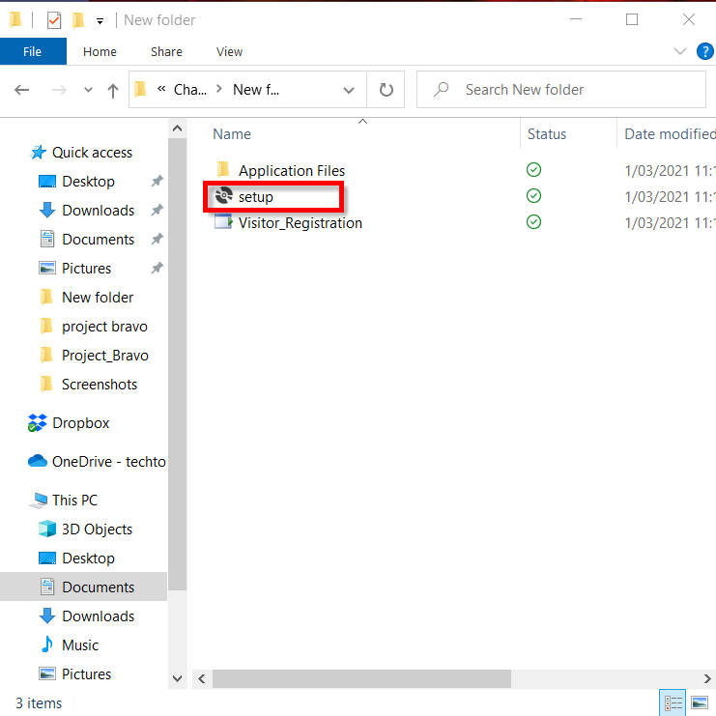

Step 2 : Enter First name of visitor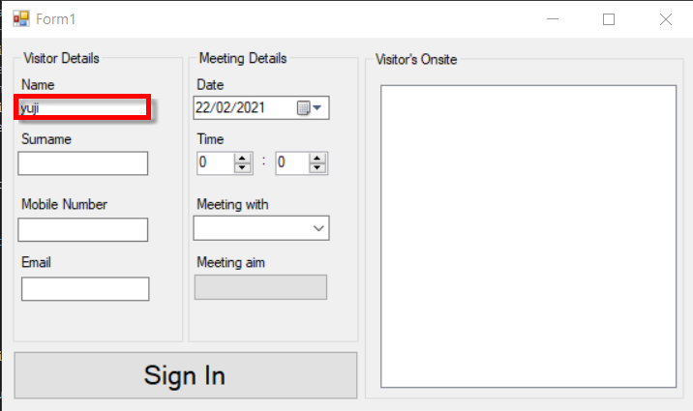

Step 3 : Enter Surname of visitor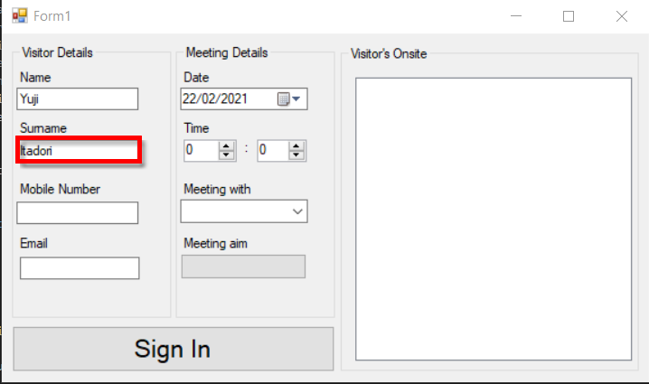

Step 4 : Enter Mobile Number of Visitor (If its not a valid number a error message will show when you try to sign in)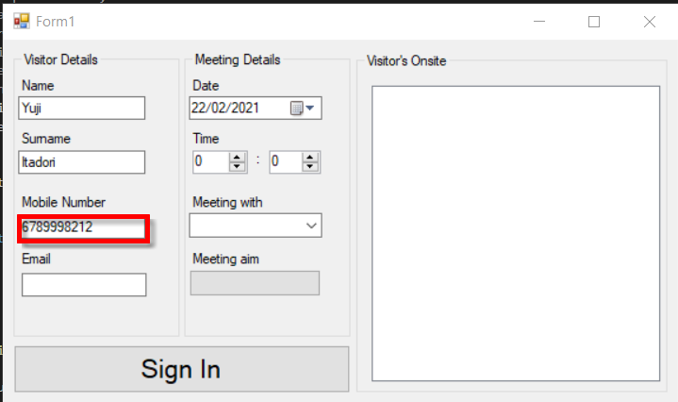

Step 5 : Enter Email Address of Visitor (If Invalid Email is enter then another error message will show when you try to sign in)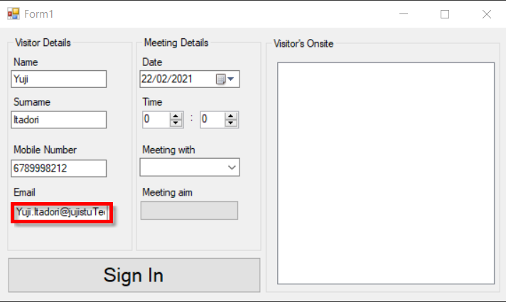

Step 6 : Enter the date of meeting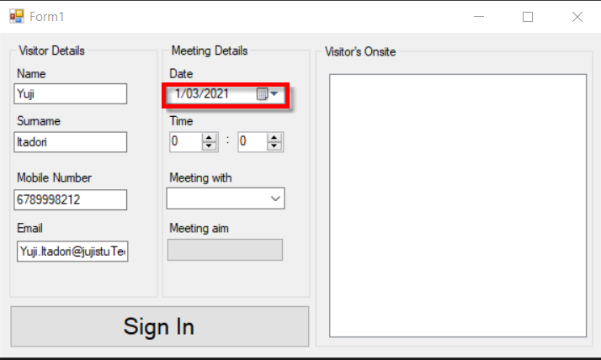

Step 7 Enter the time of meeting (Hour id the first hours and minutes is the second as shown) 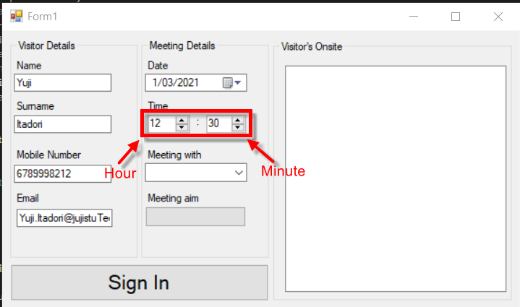

Step 8 : click the pull down box and select from list who the visitor is meeting with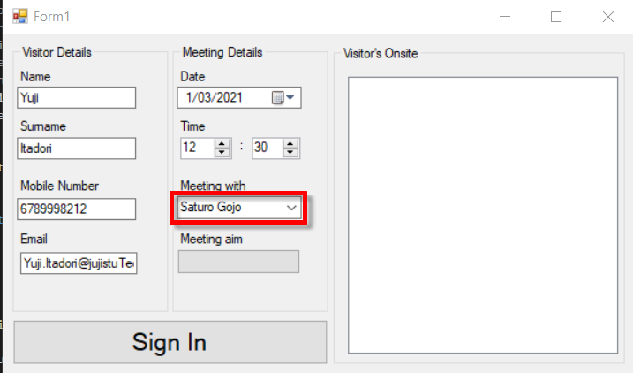

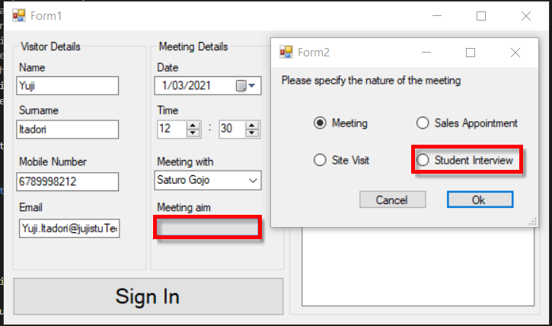Step 9 : Click meeting aim box and another form will pop up as shown, then from the following opition select the reason for the visit eg. Student Interview

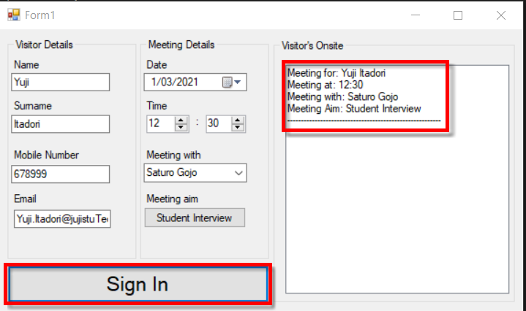Step 10 : Sign In, If all step were followed then the information you enetred will show in the visitors onsite text box shown in the example